Reutlingen Campus Computer Network Plan

|  |
| --- |
| Reutlingen University  Established - 1855  Budget - 55,3 M €  Academic staff - 158  Administrative staff - 442  Students - 5500  Location - Reutlingen, Baden-Württemberg, Germany |

Reutlingen University is a [university of applied sciences](https://en.wikipedia.org/wiki/Fachhochschule), consisting of five schools (School of Applied Chemistry, [ESB Business School](https://en.wikipedia.org/wiki/ESB_Business_School), the School of Information Technology, the School of Engineering and the School of Textiles & Design).

The campus sits on the southwestern edge of [Reutlingen](https://en.wikipedia.org/wiki/Reutlingen), close to recreation and sport areas (including the [city soccer](https://en.wikipedia.org/wiki/SSV_Reutlingen) stadium).

Campus plan

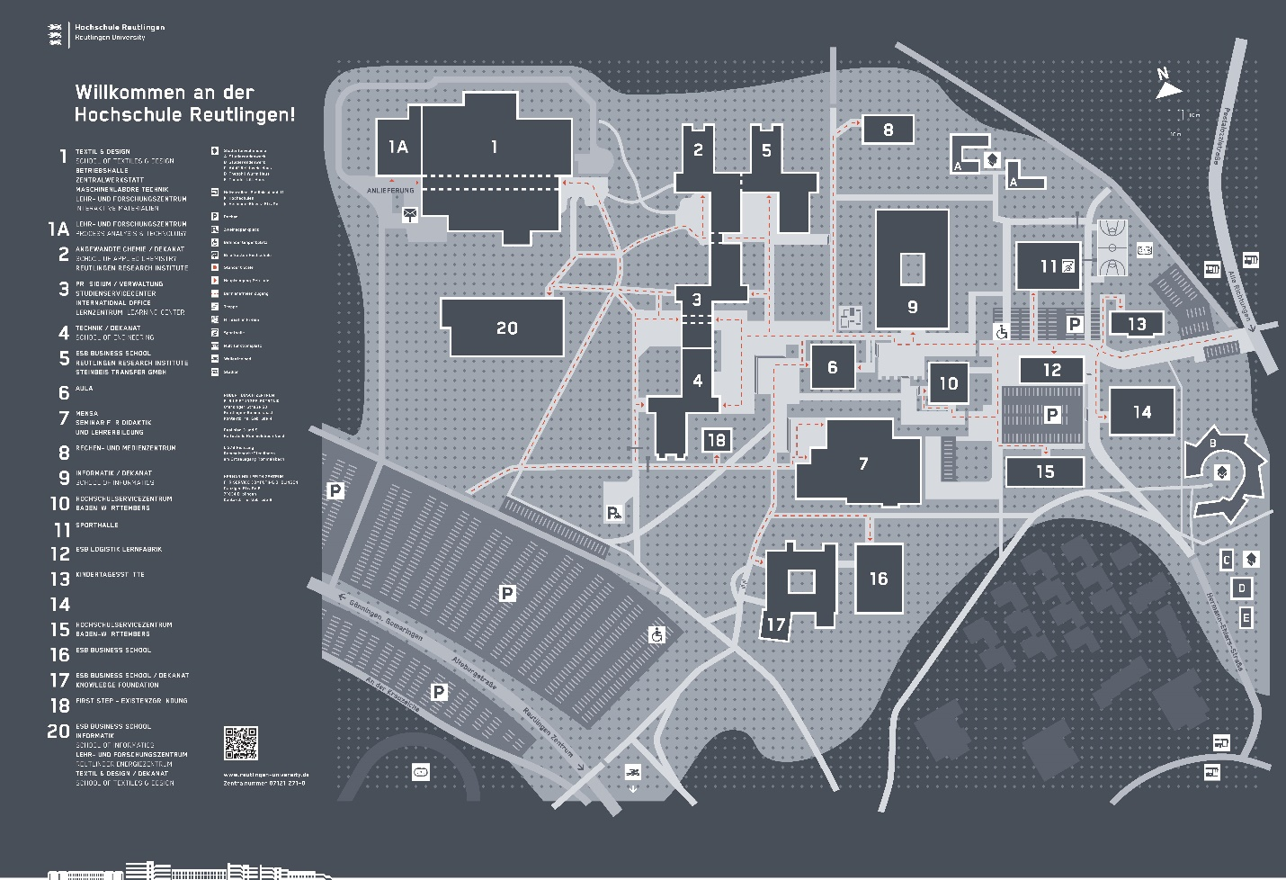 It consists of 23 buildings: 7 hostels, buildings dedicated to the degree programs, an aula, a computer and media center, a learning center, a cafeteria, a gym and a day care center. In addition it has a parking lot with 1500 spaces.

The Computer and Media center provides IT services.

Number of subnetworks : 7

* 7,17,16
* 20,4,18
* 9,6,10
* 3,1
* 2,5,8
* A,11,12,13,15
* 14,B,C,D,E